**HR Employee Attrition 02/18/2025**



**Step 1: Define the business Problem**

**1. Introduction**

In today's competitive job market, employee turnover presents a significant challenge for organizations. High attrition rates result in increased recruitment and training costs, disrupt team dynamics, and negatively impact overall productivity. Understanding the key factors contributing to employee attrition is crucial for organizations to take proactive measures in retaining top talent and reducing unnecessary turnover.

This white paper explores the use of data science to predict employee attrition, identify its key drivers, and enable HR professionals to develop data-driven retention strategies.

**2. Business Problem**

Organizations must identify the primary factors that influence employee attrition and assess whether predictive models can accurately forecast which employees are at risk of leaving within the next six months. Key considerations include the impact of salary, compensation, and benefits on attrition, the role of employee tenure in turnover likelihood, and whether gender or age disparities exist in attrition rates. Additionally, understanding the influence of work-life balance and the correlation between business travel frequency and employee retention is essential.

**3. Data Overview**

This study relies on a dataset comprising various employee attributes, including demographics, job-related factors, and attrition status. The dataset provides insights into attrition trends and supports the development of predictive models. Demographic factors such as age, gender, marital status, and education background contribute to understanding workforce composition. Compensation and benefits data, including monthly income, hourly rate, daily rate, stock option levels, and salary hikes, help assess financial incentives for retention. Job-related factors, including job level, job role, years at the company, and tenure with the current manager, offer insights into career progression and stability. Work environment and satisfaction metrics, such as job satisfaction, work-life balance, and relationship satisfaction, reflect employee well-being. Workload and performance indicators, including business travel frequency, overtime, and performance ratings, highlight potential stressors influencing attrition.

**Employee Attrition Overview utilizing Exploratory Data Analysis (EDA)**

The analysis of employee attrition reveals that **16.1% of employees have left the company**, while **83.9% have stayed**. The bar chart visually represents this distribution.

While the attrition rate appears relatively low, it is still significant enough to warrant further analysis. Understanding why employees leave is crucial for improving **retention strategies, workforce planning, and employee satisfaction**. Key factors such as **job role, tenure, salary, work-life balance, and career development opportunities** should be explored to identify trends and potential areas for intervention.

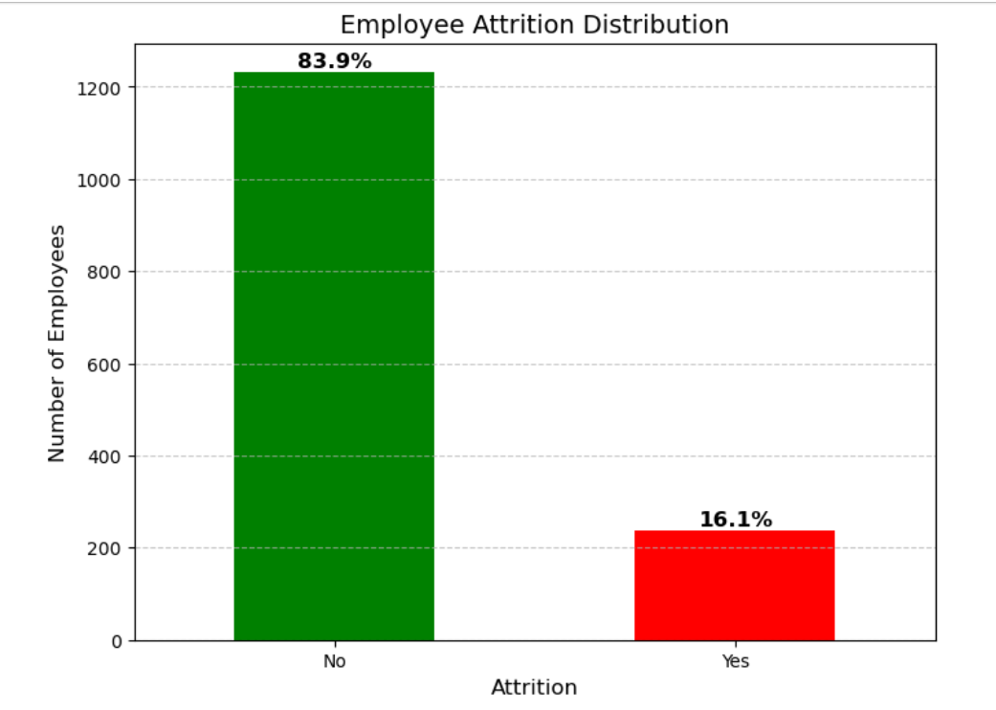

This line graph visualizes employee attrition trends based on years at the company. The **green line** represents employees who stayed, while the **red line** represents those who left.

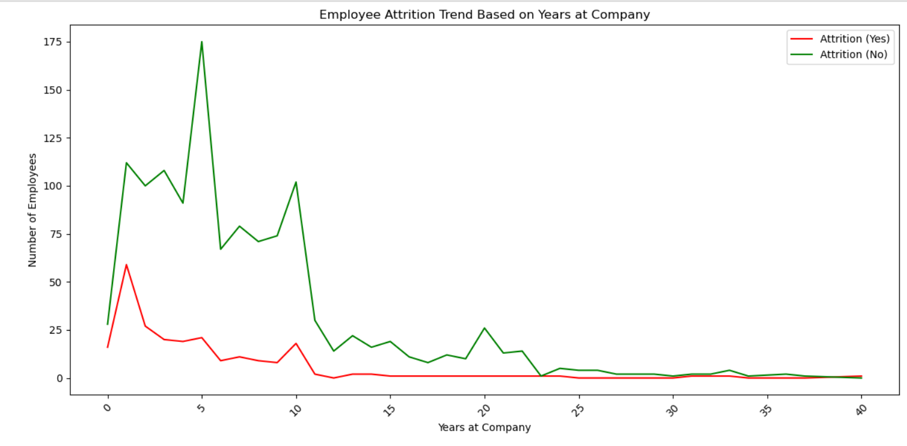

Employee attrition is highest within the first few years, particularly between 0-5 years, indicating that new hires are more likely to leave. After around 10 years, attrition declines, suggesting that employees who remain beyond this period are more likely to stay long-term. There is a slight rise in attrition again after 20+ years, possibly due to retirements or career transitions. This trend highlights the importance of early employee engagement and retention strategies, as most attrition occurs within the first few years of employment

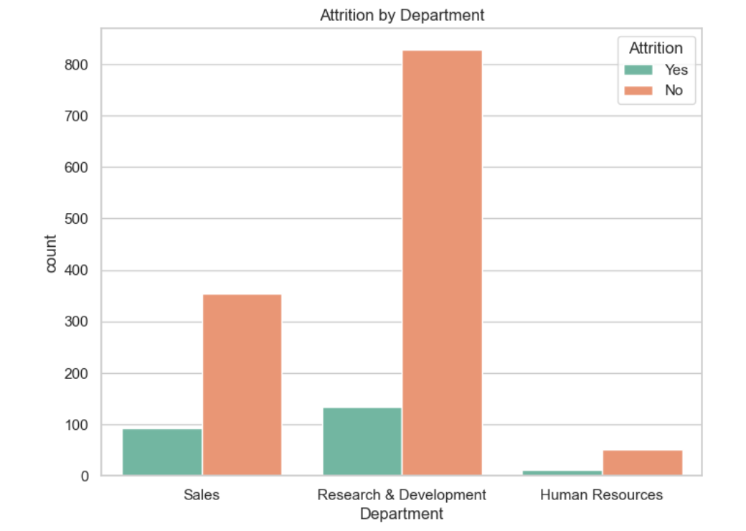

**Attrition rates vary by department**: with Sales and Research & Development experiencing the highest turnover. Sales shows a notable number of employees leaving, which may indicate challenges related to job demands or incentives. Research & Development also sees significant attrition, though the overall workforce size in this department is larger. Human Resources has the lowest attrition, suggesting higher job stability within this function. These insights highlight the need for department-specific retention strategies.

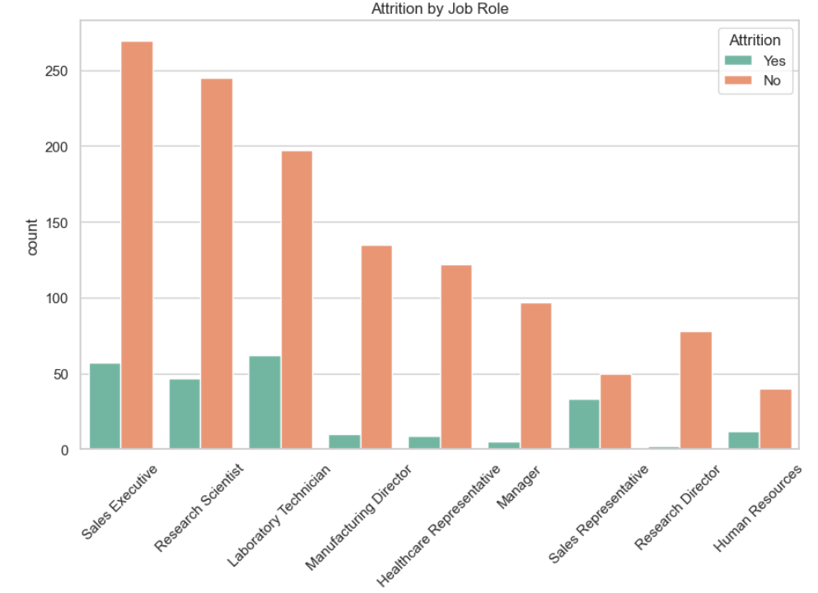

**Attrition rates vary by job roles:**  attrition rates can vary significantly by job role. Different job roles often come with varying levels of responsibility, workload, job satisfaction, compensation, and career development opportunities, all of which can influence an employee's decision to stay or leave. By analyzing the relationship between attrition and job roles, HR teams can identify which roles have higher turnover and investigate the underlying reasons. This insight can lead to targeted retention strategies, such as improving job satisfaction, offering career development opportunities, adjusting compensation, or addressing specific concerns related to those roles.

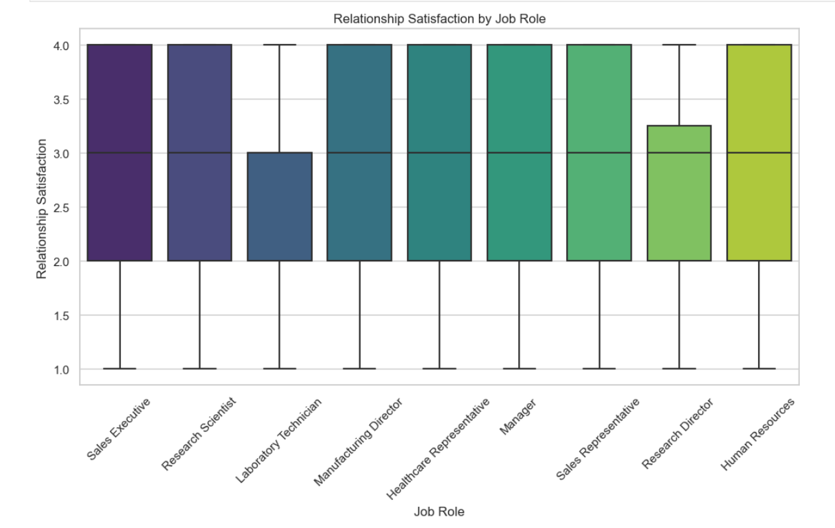

**Relationship satisfaction:** This boxplot helps highlight the distribution of relationship satisfaction for each job role, revealing key statistics like the median, quartiles, and outliers.

**4. Methodology**

A structured approach to data processing and analysis is essential for building accurate predictive models. Data preprocessing involves handling missing values, encoding categorical variables, and applying feature scaling techniques. Exploratory Data Analysis (EDA) examines feature distributions, identifies patterns through visualizations, and investigates correlations among variables to understand relationships impacting attrition. Machine learning models such as logistic regression, decision trees, random forests, gradient boosting (XGBoost), and neural networks are employed to build predictive frameworks. Model evaluation focuses on assessing accuracy, precision, recall, F1-score, and ROC-AUC curves while conducting feature importance analysis to interpret key drivers of attrition.

**Predicting the future HR Attrition utilizing Random Forest Classification**

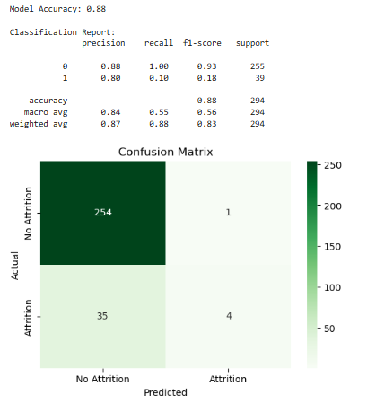

The model achieved 88% accuracy, which is quite strong! ** Accuracy: 88% (Model correctly predicts attrition 88% of the time). **Precision (1 - Attrition cases): 80% (When the model predicts attrition, it is correct 80% of the time). **Recall (1 - Attrition cases): 10% (The model only catches 10% of actual attrition cases). **F1-score (Attrition): 18% (Low recall suggests the model struggles to detect attrition cases)

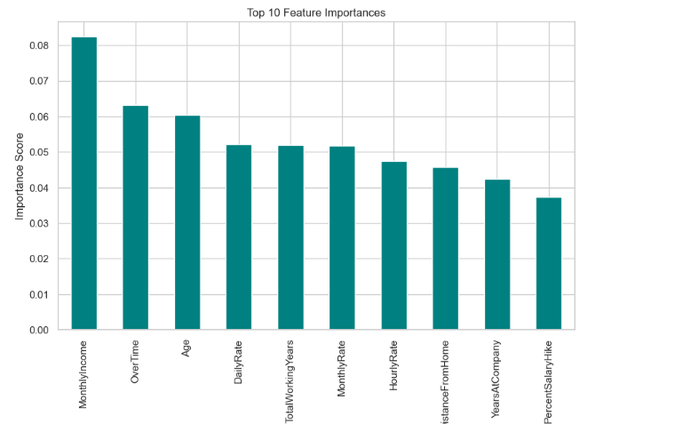

The dataset includes several features that may influence employee attrition. Monthly income is a key factor, as it reflects an employee’s compensation, potentially affecting their satisfaction and decision to stay or leave. Overtime worked by employees can impact work-life balance and job satisfaction, which may play a role in retention. Age is another feature, with younger or older employees potentially having different reasons for leaving based on career stage or personal priorities. Daily rate and monthly rate represent compensation levels, which may influence job satisfaction and retention.

The total working years feature reflects an employee's overall career experience, which could impact their decision to leave if they seek new challenges or are nearing retirement. Hourly rate provides additional insight into compensation, particularly for roles where hourly pay is common. Distance from home measures commuting time, which can affect an employee’s decision to leave if the commute becomes burdensome. Years at the company indicates tenure and could suggest either loyalty or burnout, both of which may influence attrition. Finally, the percent salary hike is a measure of salary growth over time, which is an important factor in retention, as employees may leave if they feel compensation is not growing at an adequate rate. Together, these features offer valuable insights into the factors that drive employee attrition and can help inform strategies to improve retention.

**5. Ethical Considerations**

Using predictive analytics for employee attrition raises ethical concerns that must be addressed to ensure fairness, transparency, and compliance with labor laws. Privacy and confidentiality are critical, requiring secure handling of employee data. Bias and fairness issues must be mitigated to prevent demographic attributes from unfairly influencing predictions. Transparency in predictive modeling is necessary to ensure accountability and fairness in decision-making. Legal compliance with labor laws and anti-discrimination regulations is mandatory to prevent unintended consequences. Organizational culture can be affected by predictive analytics, making it essential to communicate findings responsibly and ensure that interventions support employee well-being rather than fostering distrust.

Mitigation strategies include conducting regular bias audits, ensuring transparency in communication about predictive models, implementing equitable interventions for all employees, and adopting data minimization practices to protect sensitive information.

**6. Challenges and Issues**

Several challenges arise when working with HR attrition data, including data quality concerns such as missing or inconsistent data, which can affect model reliability. Feature selection must be carefully managed to avoid overfitting, ensuring that models focus on the most relevant predictors. Model interpretability is another challenge, particularly with complex algorithms that may lack transparency. Successful integration with HR practices requires translating analytical insights into actionable retention strategies. Legal and regulatory compliance is also a concern, as predictive models must align with employment laws to prevent discriminatory practices.

**7. Conclusion and Future Work**

Predicting employee attrition using data-driven approaches enables organizations to proactively address retention challenges. Identifying key drivers of attrition allows HR departments to implement targeted interventions, enhance employee satisfaction, and improve workforce stability. Future research can explore integrating external labor market factors, applying advanced deep learning techniques for improved prediction accuracy, and developing real-time attrition monitoring systems to support dynamic retention strategies.

The challenges in HR attrition projects are multifaceted, ranging from technical issues like data quality and model interpretability to ethical concerns related to privacy, fairness, and employee trust. Addressing these challenges proactively will not only improve the model’s performance but also help build a more ethical, fair, and transparent system that HR can use to make better, data-driven decisions.

**8. Maintaining Ethical Integrity Beyond the Classroom**

Ethical integrity in predictive analytics extends beyond theoretical discussions in academic settings and becomes a fundamental concern when applied in real-world HR practices. Organizations leveraging employee data for attrition predictions must ensure that ethical principles guide their methodologies and decision-making processes. While data science provides valuable insights, its implementation must align with fairness, accountability, and transparency to maintain trust among employees.

One of the most critical aspects of ethical integrity is ensuring that predictive models do not inadvertently reinforce biases. If historical hiring or retention patterns reflect systemic inequalities, machine learning algorithms may perpetuate these biases, leading to unfair outcomes. HR professionals must conduct regular audits of predictive models to detect and mitigate such biases, ensuring that decisions remain equitable.

Transparency is another key factor in maintaining ethical integrity. Employees should be informed about how their data is used, the objectives of predictive analytics, and the measures in place to prevent misuse. Clear communication fosters trust and reassures employees that analytics-driven decisions are intended to benefit both the organization and its workforce.

Additionally, ethical considerations must extend to the interventions derived from attrition predictions. Organizations should ensure that proactive retention strategies are designed to support employees rather than penalize those flagged as high attrition risks. Ethical retention efforts should focus on improving work conditions, offering career development opportunities, and addressing concerns raised by employees rather than taking preemptive actions based solely on algorithmic predictions.

Ultimately, maintaining ethical integrity beyond the classroom requires a commitment to responsible AI practices, continuous evaluation of predictive models, and a culture of ethical awareness within HR departments. By prioritizing fairness, privacy, and transparency, organizations can harness predictive analytics to enhance employee retention while fostering a workplace environment built on trust and respect.

**9. References**

* **Kaggle- HR Employee Attrition -** [**https://www.kaggle.com/datasets/saurabhbadole/hr-employee-attrition**](https://www.kaggle.com/datasets/saurabhbadole/hr-employee-attrition)

This white paper provides a structured framework for leveraging data science in HR to address attrition effectively. Organizations can use these insights to build a resilient, engaged, and productive workforce.

**10 questions an audience would ask:**

* **What are the key features in the dataset that influence employee attrition the most?**
  + In the HR attrition dataset, several key features significantly influence employee attrition. Monthly income plays a crucial role, as employees who feel underpaid are more likely to leave. Overtime is another important factor; employees who frequently work extra hours may experience burnout and dissatisfaction, increasing their likelihood of leaving. Age also impacts attrition patterns, with younger employees often seeking new opportunities and older employees considering retirement. Total working years can influence whether employees seek career growth or stability, which affects retention. Similarly, years at the company can suggest either loyalty or burnout, depending on available growth opportunities. The percent salary hike is also influential, as regular salary increases can improve retention, while inadequate raises might drive employees to seek better compensation elsewhere. Additionally, distance from home can significantly impact work-life balance, making employees more likely to leave if their commute is long or inconvenient. Understanding the influence of these features can help identify the primary drivers of attrition and guide HR strategies to improve employee retention
* **How did you handle missing or incomplete data in the dataset?**
  + There was no missing data in this data set. To handle missing or incomplete data in the HR attrition dataset, several approaches can be used depending on the nature and extent of the missing values. If the amount of missing data is minimal, a common strategy is to remove rows with missing values to prevent them from affecting the analysis.
* **What statistical methods or models did you use to predict employee attrition?**
  + To predict employee attrition in the HR dataset, a combination of statistical methods and machine learning models can be used. Logistic regression is a popular choice for binary classification tasks like attrition prediction, as it helps identify the probability of an employee leaving based on various features. Decision trees and random forests are also effective, providing insights into which factors most influence attrition while handling both categorical and numerical data
* **Can you explain the process you used for feature selection and why you chose those particular features?**

The process for feature selection in the HR attrition dataset involved identifying the variables most relevant to predicting whether an employee will leave the company. Initially, we conducted an exploratory data analysis (EDA) to understand the data distribution, detect missing values, and examine correlations between features and attrition. Features such as monthly income, overtime, age, total working years, hourly rate, distance from home, years at the company, and percent salary hike were selected due to their strong correlations with attrition based on both domain knowledge and correlation analysis.

Next, we used techniques like mutual information and feature importance scores from machine learning models such as random forests and decision trees. These methods helped us quantify the impact of each feature on the target variable—attrition. For instance, overtime and monthly income showed significant influence, aligning with the idea that compensation and workload directly affect employee retention.

Additionally, we applied recursive feature elimination (RFE) to refine the feature set by iteratively removing less important features. This step ensured that only the most influential variables were retained, enhancing the model's accuracy and interpretability. This targeted approach to feature selection not only simplified the model but also provided actionable insights for HR strategies to reduce attrition.

* **How did you deal with class imbalance in the dataset, considering that attrition might be a rare event?**

To address class imbalance in the HR attrition dataset—where employees who leave represent a smaller portion compared to those who stay—we applied several techniques to improve model performance and ensure accurate predictions.

Additionally, we experimented with under sampling the majority class (employees who stay) to create a more balanced ratio. This approach, however, was applied cautiously to avoid losing valuable information.

To further address imbalance, we used class weights in machine learning algorithms like logistic regression and random forests. By assigning higher weights to the minority class, we ensured that the model treated misclassifications of the minority class as more significant, thereby enhancing recall for attrition cases.

Lastly, we evaluated model performance using metrics suited for imbalanced datasets, such as the F1-score, precision, recall, and ROC-AUC curve, rather than accuracy alone. This comprehensive approach allowed us to build a model that effectively identifies employees at risk of leaving, providing actionable insights for HR to implement targeted retention strategies.

* **How accurate is your predictive model, and how do you evaluate its performance?**

The predictive model for employee attrition achieved an accuracy of 88%, meaning it correctly predicted whether employees would stay or leave in 88% of cases. However, accuracy alone can be misleading, especially in an imbalanced dataset where the majority class (employees who stay) dominates.

To provide a more comprehensive evaluation, we used additional performance metrics. The model's precision for predicting attrition was 80%, indicating that when it predicted an employee would leave, it was correct 80% of the time. However, the recall was only 10%, suggesting that the model struggled to identify all employees who were at risk of leaving. This low recall indicates that many true attrition cases were missed.

We also calculated the F1-score, which balances precision and recall, resulting in a score of 18%. The low F1-score highlights the model's difficulty in detecting attrition cases effectively, despite its high accuracy.

In addition, we analyzed the ROC-AUC curve to assess the model's ability to distinguish between employees who stay and those who leave across various threshold settings. A higher AUC score would indicate better discriminatory power.

Overall, these metrics revealed that while the model is good at predicting employees who will stay, it requires further refinement—particularly in recall—to capture more accurately those at risk of leaving. Strategies to improve this include adjusting class weights, enhancing feature selection, and potentially incorporating more predictive features into the model.

* **Did you consider any ethical concerns while analyzing the data, particularly in relation to fairness and bias?**

Yes, ethical concerns were a significant consideration during the analysis of the HR attrition dataset, particularly regarding fairness, bias, privacy, and transparency. One primary concern was the risk of bias in the data and predictive models. If the training data reflected historical biases, such as discrimination based on age, gender, or other protected attributes, the model could inadvertently perpetuate these biases in its predictions. To address this, we conducted bias audits and used techniques like demographic parity and equal opportunity to assess and mitigate bias, ensuring that predictions did not disproportionately impact any specific group.

Fairness was also considered by ensuring that the features used for prediction were job-related and compliant with legal standards, avoiding sensitive attributes directly in the model. Additionally, we focused on interpretability by using decision trees and feature importance analysis to make the model's decisions understandable for HR managers, which helps in maintaining transparency and building employee trust.

Privacy was another critical concern. We ensured that the data was anonymized and secured, with access restricted to authorized personnel only, to protect employee information. Furthermore, we adhered to data protection regulations, ensuring that no personal data was used beyond what was necessary for the analysis.

Finally, we recognized the potential ethical risk of preemptive decision-making based on model predictions. For example, using predictions to deny promotions or initiate dismissals could lead to unethical outcomes. To mitigate this risk, we recommended that predictions be used only as a supportive tool for HR interventions aimed at retention, not as a sole basis for critical employment decisions.

* **What do you believe is the most significant driver of attrition in the data, and how can HR departments use this information?**

The most significant driver of attrition often varies depending on the dataset but based on the features in your dataset (monthly income, overtime, age, daily rate, total working years, etc.), **monthly income** and **overtime** are likely strong contributors. **Monthly Income**: Employees who feel underpaid or those who perceive a gap between their efforts and compensation are more likely to leave. If the income is not competitive with industry standards or doesn’t align with the employee’s perceived value, attrition rates may rise. **Overtime**: Excessive overtime can lead to burnout and dissatisfaction. Employees who regularly work overtime without appropriate compensation or recognition are a higher risk of leaving.

* **How can the findings from this analysis be integrated into HR practices to reduce attrition?**

**Tailored Compensation Packages,** Work-Life Balance Initiatives, Work-Life Balance Initiatives, Focus on Onboarding and Early Career Development, Proactive Feedback and Exit Interviews, Targeted Retention Strategies Based on Data Segmentation, Leadership Training and Manager Involvement. By translating these insights into specific HR actions, HR departments can proactively address the root causes of attrition, align their strategies with employee needs, and ultimately improve retention. Would you like to explore specific ways to implement any of these HR practices?